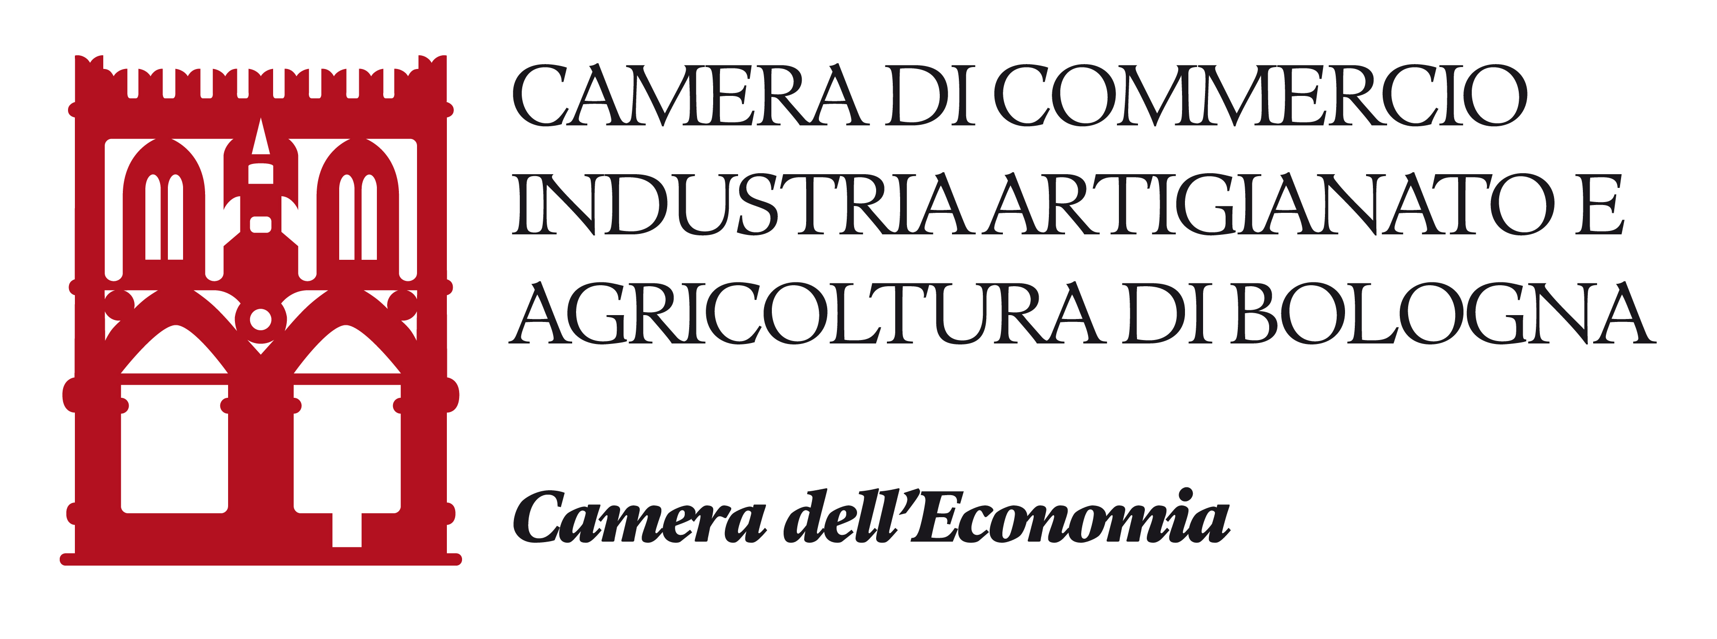

COMPANY PROFILE

PROGETTO
“EMILIA-ROMAGNA FASHION – Nuovi orizzonti verso la Russia – II annualità

Da inviare entro il 12/03/2018 via e-mail all’indirizzo PEC: promozionestera@bo.legalmail.camcom.it

COMPANY NAME
ADDRESS
POSTCODE CITY PROVINCE
PHONE FAX
HOME PAGE (mandatory requirement)
NUMBER OF EMPLOYEES | 2015 | 2016 | 2017
TURNOVER (Mln. €)  2016  2017 | EXPORT TURNOVER (%)  2016  2017
CONTACT PERSON |  | Job Title
E-MAIL
PHONE |  | Mob.
LANGUAGES

- ACTIVITY AND PRODUCTS
Activity Sector
Product description | Duty code
Certifications (EAC, etc…)
Field/s of application of your products/services
End-user of your products/services

- COMMERCIAL PROFILE
Your Export destination countries:
Country | %Export | Type of customer (agent, manufacturer, importer/distributor, etc..) | Other informations
Main factor/s of competitiveness of your company:
- Design Ratio price/quality
- Quality Brand name/Presentation
- Technology Range of products
Your presence in foreign markets:
- Direct Joint venture
- Representative Importer/Distributor
- License Other (specify) ___________________
Main Competitors:
COMPANY | COUNTRY

- MARKET INFORMATION
Previous experience in the target country (if any, please specify country and type of customer, for example “Russia, importer”)
Is your company in contact with local companies? Yes No
Would you like to contact any specific company? Yes No
If yes, specify the name and the address
NAME | ADDRESS | TELEPHONE | CONTACT PERSON
Is there any specific company you want NOT to contact? Yes No
If yes, specify the name and the address
NAME | ADDRESS | TELEPHONE | CONTACT PERSON
Please specify the type of partner you are looking for

